الاسم: مازن بهجت ساعود

الرقم الجامعي: 1921

رقم الوظيفة: 1

المادة: برمجة شبكات

First Network Programming Homework

**Question 1:**

**A-**Define a list that contain the names of graduated students” 5 students at least”:

Create a program that accept student name and prints if the user is graduated or not.

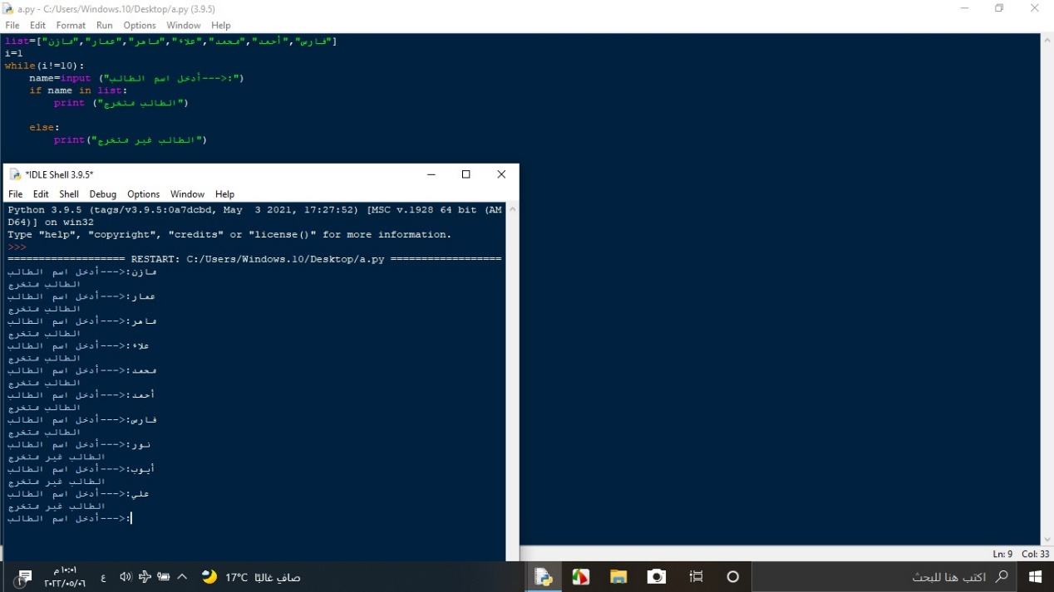

B**-** Generate and print a list of odd numbers from 1 to 1000.

Tips: “List Comprehension”

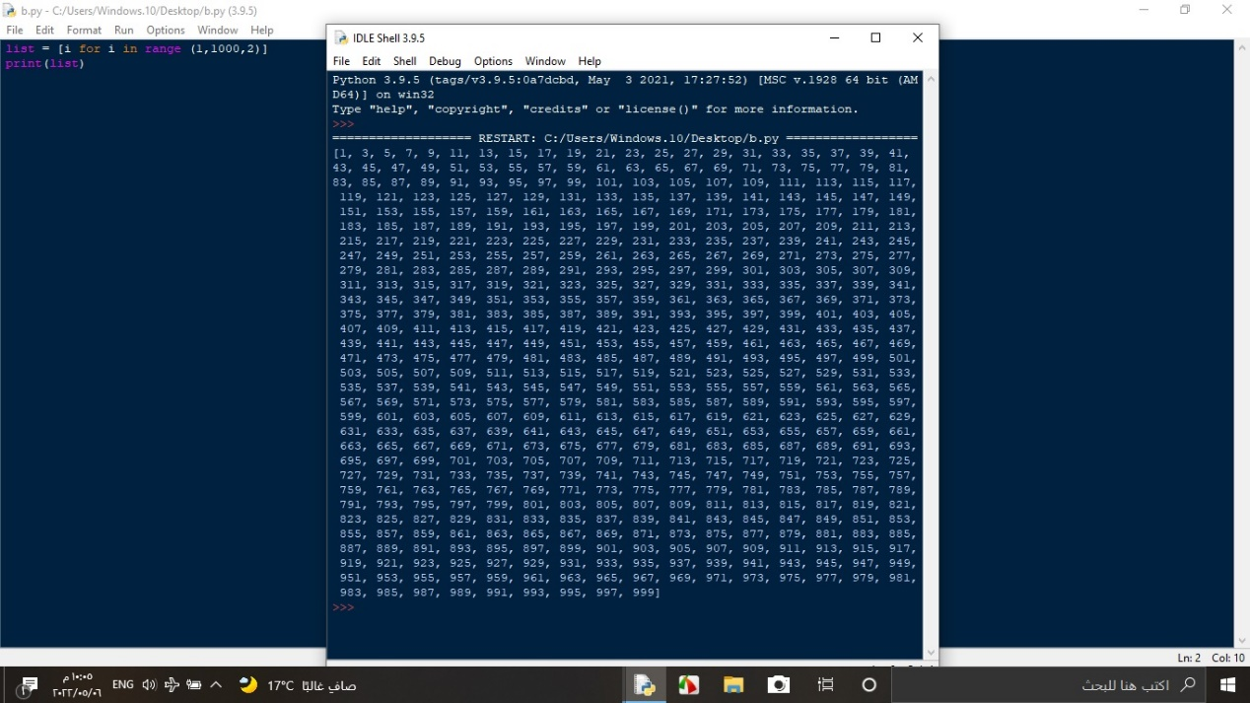

**C**- L=[‘Network’ , ’Math’ , ’Programming’, ‘Physics’ , ‘Music’]

In this exercise, you will implement a Python program that reads the items of the previous list and identifies   
 the items that starts with ‘P’ letter, then print it on screen.  
 Tips: using loop, list ‘len ()’ method

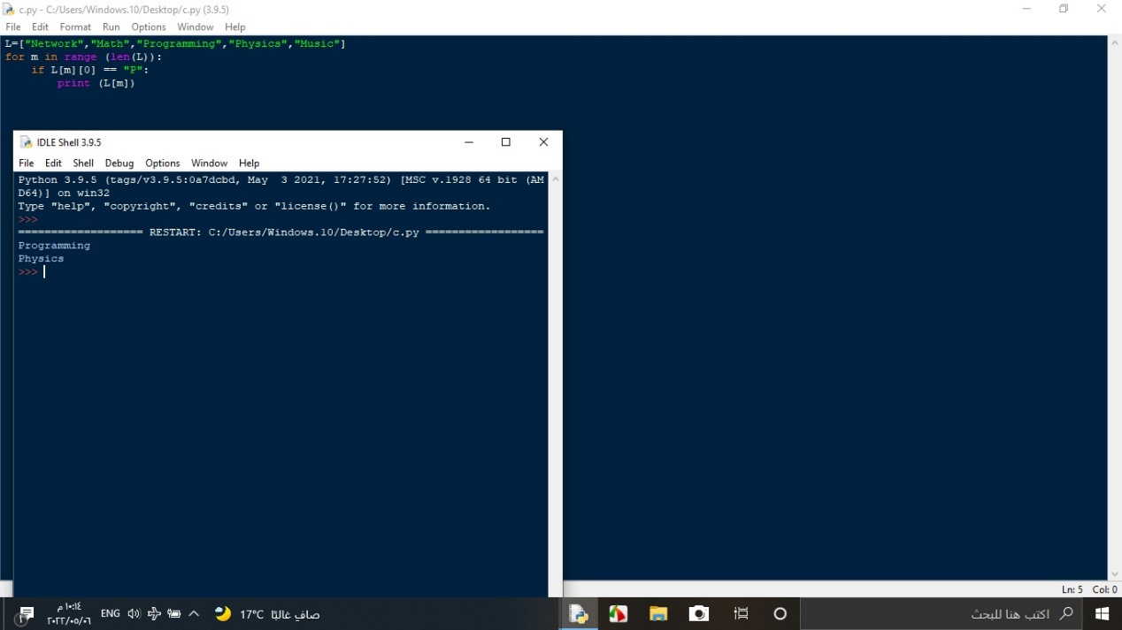

**D**: Using Dictionary comprehension, Generate this dictionary d={1:1,2:4,3:9,4:16,5:25,6:36,7:42,8:64,9:81,10:100}

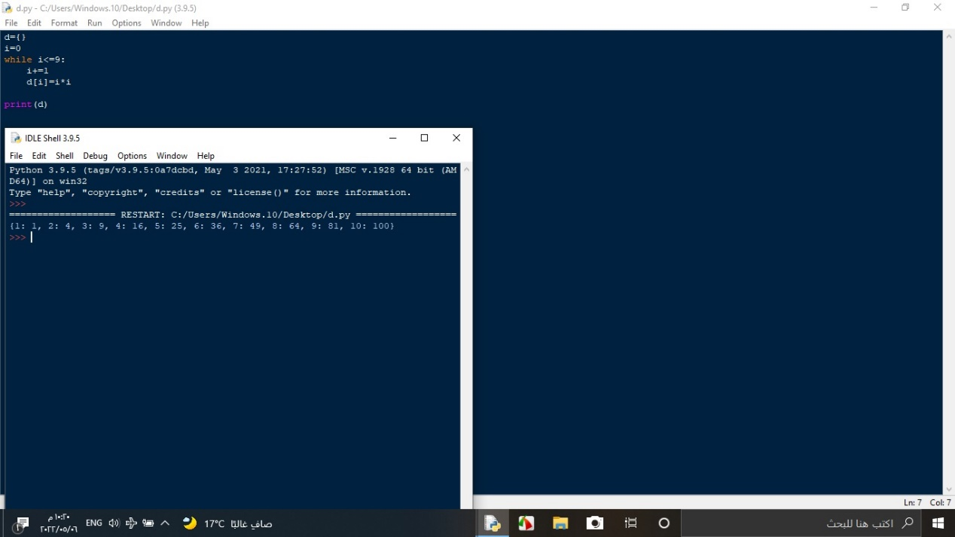

**Question 2:** Convert from decimal to binary

Write a Python program that converts a decimal number into its equivalent binary number.

The program should start reading the decimal number from the user. Then the binary equivalent number must be calculated. Finally, the program must display the equivalent binary number on the screen.

Tips: use empty list to hold binary number, use loop, use % operator, use // operator, use list append method, reverse the list.

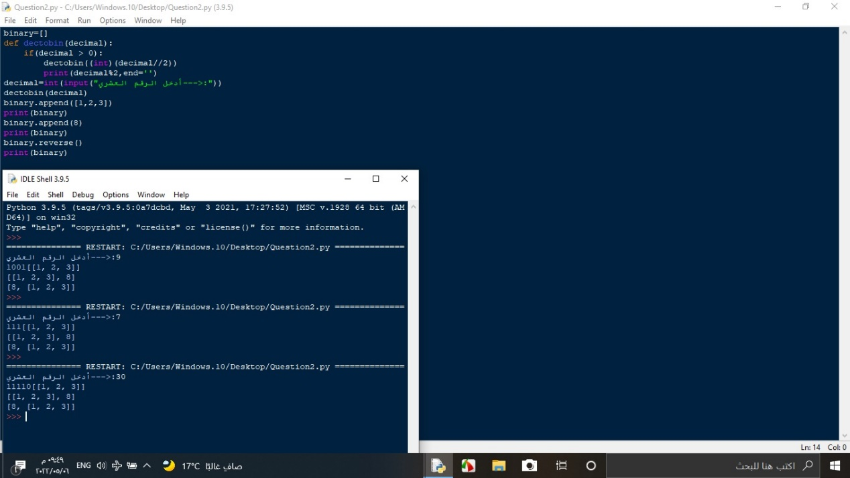

**Question 3:** Working with Files” Quiz Program”

Type python quiz program that takes a text or json or csv file as input for (20 (Questions, Answers)). It asks the questions and finally computes and prints user results and store user name and result in separate file.

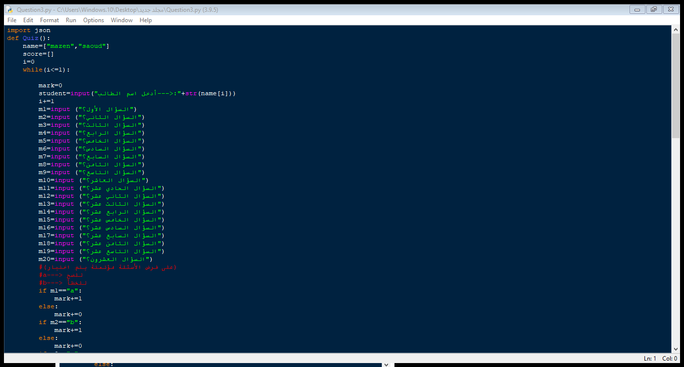

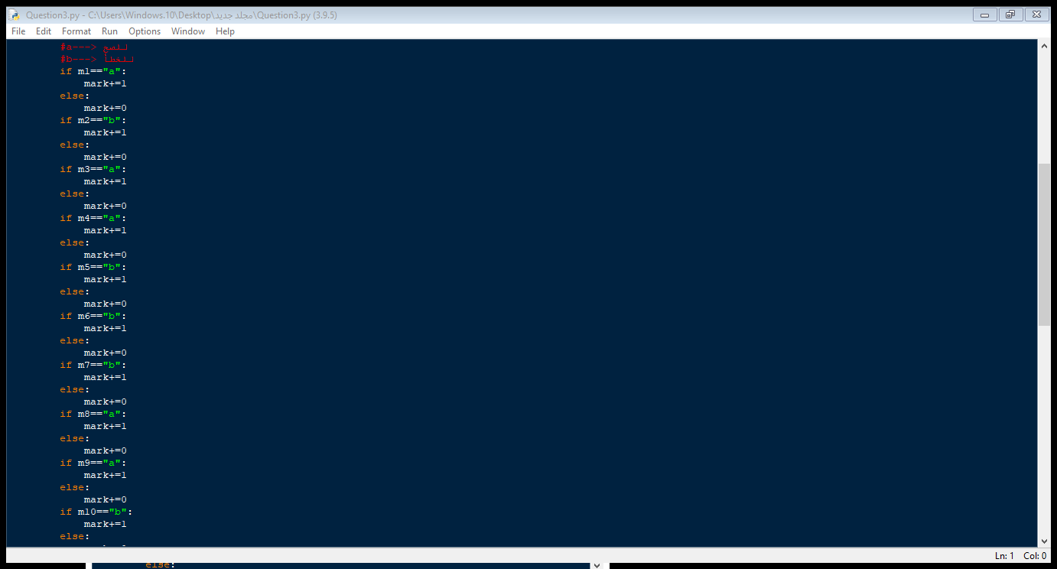

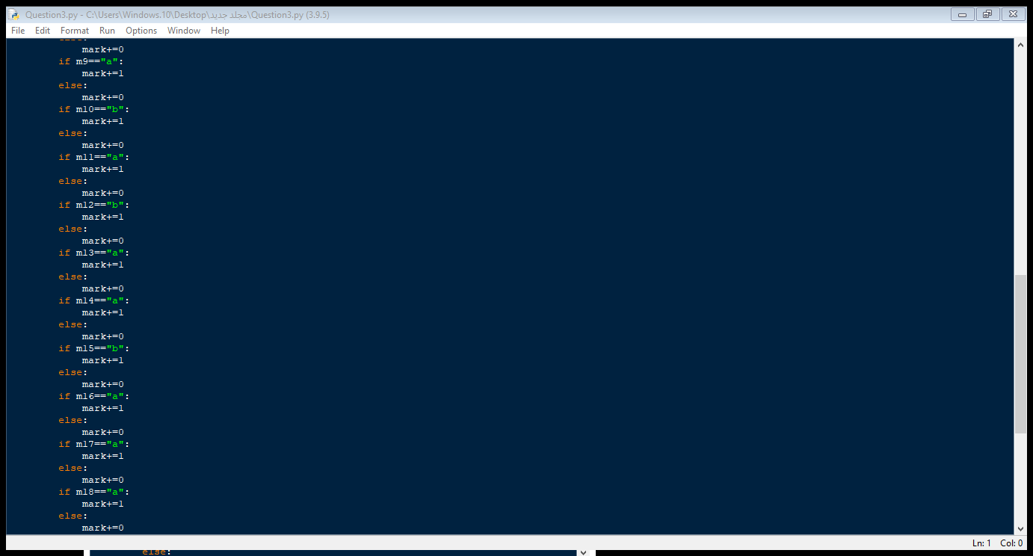

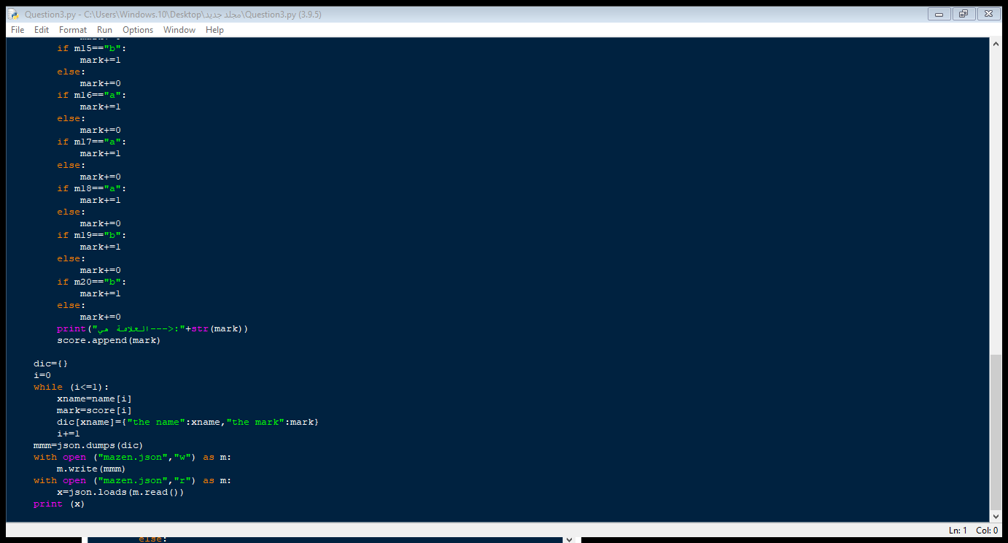

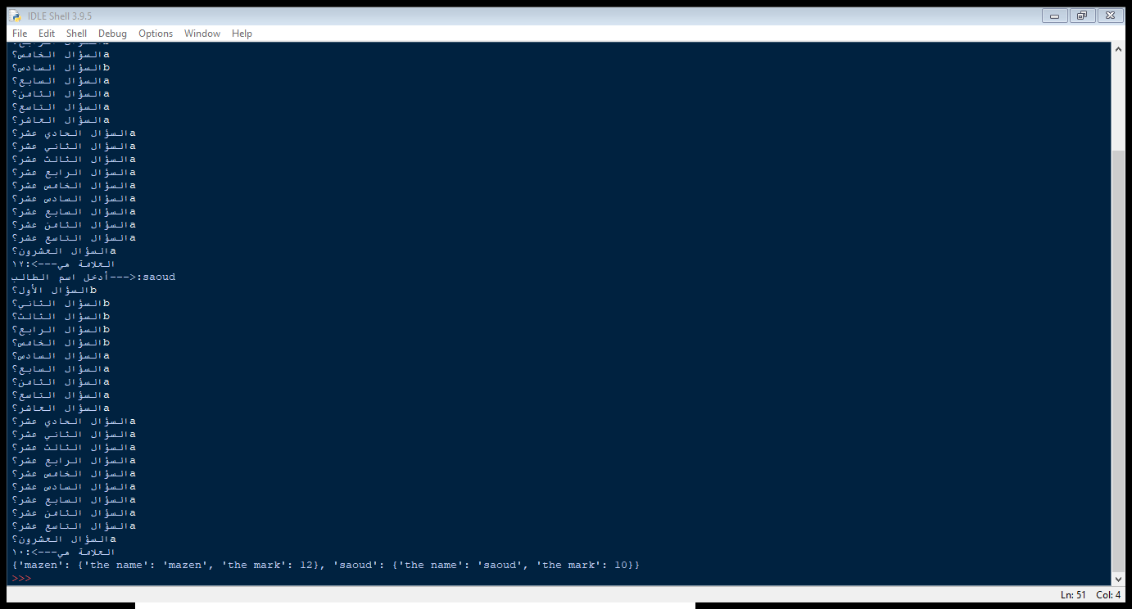

ملف ال json

